Nepal College of Information Technology
Assessment-2009

Program: BE Time: 3 hrs
Semester: Spring FM: 100
Subject: Analog communication PM: 50

Attempt all the questions.
1. a). Discuss block diagram of communication system .Enlist the differences between analog and digital transmission system.
b). "Figure of merit in communication system is Signal to Noise ratio i.e. SNR". Discuss and Elaborate the difference between distortion and interference.
2 a) Define capture and threshold effect in FM. Why premphasis and de emphasis are used in FM? Evaluate
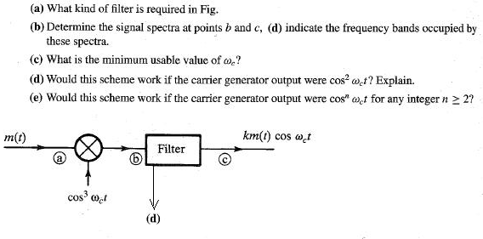
b). What is carrier reinsertion in SSBSC? Derive an expressions for the representation of frequency and phase error on local oscillator.
3 a). Enlist 3 properties of Bessel functions and hence derived power relation in FM. How PLL is used in FM demodulation? Derive expressions.
b) Compare and contrast between monophonic and stereophonic transmission along with the working mechanism of FM stereo transmitter and receiver.

4 a). Discuss types of satellites on the basis of orbits. How different multiple access techniques are implemented in telephony?
b). What is uplink, downlink and transponder? Discuss channel sharing in transponder with diagram.
5 a). What are FDM vs FDMA? Derive analog telephone hierarchy from CCITT group super group and master group with sketch of frequency spectrum.
b). Compare FM and PM. For the fig. shown below
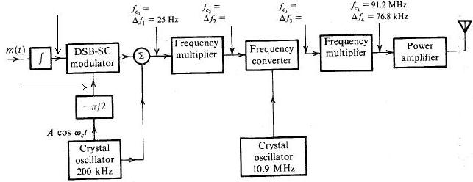
- Discuss the phenomenon and the person behind the invention.
- What are the mathematical expressions at the point shown by arrows? Derive.
- What will be the values of parameters in figure? Calculate
- What will be the value of multipliers in use? evaluate
6 a.
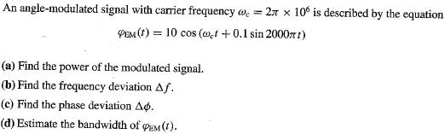

b). Explain working mechanism of Radio communication system. Compare and contrast between AM, FM and TV broadcasting with brief explanation of TV transmitter and receiver.
7. Write short notes on:
i.) External vs. internal noise
ii. Ring modulator

